Java mail API:-

* A Jee Module Technology.
* This api is given to interact with mail server through java application.
* Database s/w maintains data in the form of db Colum and rows.
* Jndi registry maintain object and object reference having nick name for global visibility.
  + Rmi registry, cos registry
* Mail server manage email account and email messages eg: Apache James mail server, Cmail server, Lotus mail server, MS exchange server and etc..
* Java app----uses jdbc api-------🡪DB s/w
* Java app ……..jndi api--------🡪jndi registry s/w
* Java app-----java mail api----🡪Mail server s/w

1. Send mail
2. Send mail with attachment
3. Read mail
4. Delete mail
   * + Note: -We can place java mail api code either in stand alone or in web application to perform email operations.

# Java mail api is combination of

javax.mail, javax.internate, javax.mail.activation packages………..

Jar files===========> (mail.jar, activation.jar) download from oracle.com or from jboss.

Every mail server contains two built-in server

* + Incoming Server: - capable of receiving and managing email message in the inbox of email account use IMAP /POP3 protocol to interact with this incoming server from mail clients.
  + Outgoing server:- capable of sending email message from one account to another account. Mail client use smtp protocol to interact with server.
* POP3 incoming server delete email message from the inbox of email account once it is read by mail client.
* IMAP incoming server does not delete the email message from the inbox of mails account even after it has been read by mail client.

There are two types of mail clients

1. Readymade mail clients

Eg: MS outlook, MS outlook express

1. Programmable mail clients

Eg: - Java application with java mail API code.

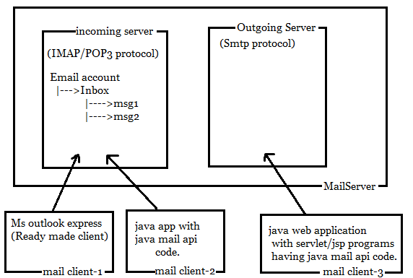

|  |
| --- |
| James mail server(apache)  Open source  32 bit  Port No:-4555 ( admin port no)  110 ((POP incoming server)  25 (SMTP) outgoing server)  119 (Network News server)  To download 🡪 download from internet as zip file (just extract it)  Server by james mail server. |

* POP3 incoming server is very useful while developing intranet mailing server.
* IMAP incoming server is very useful while developing internet mail system application like Gmail.

Procedure to create: in james mail server

|  |
| --- |
| 1. Start james mail server.<james_home>\bin\run.bat file. 2. Launch telnet tool to connect to mail server   (Program and feature   1. Connect to james mail server and create email account.   Microsoft telnet :-> open localhost 4555  Login id : root .  Password : root.  help  Adduser kalam missile  (User) (password)  Some more commands :- Listuser, Countuse, Verifyuser ………. |

# Structure of email message :-

# 

# Standard steps to send email message:-

1. Create java.util.ptoprties collection having mail property.
2. Crete session object (it is similar to jdbc connection) based on mail properties to established the connection with outgoing server of mail server.
3. Prepare email message pointing to session having header values and message body.
4. Send email message.